|  |  |
| --- | --- |
| 2020 DATA HACKATHON  **Visualizing the Inside Journey of Recovery from Opioid Use Disorder** | *“Data are just summaries of thousands of stories – tell a few of those stories to help make the data meaningful.” — Chip & Dan Heath*  Team 11  Pete Arriaza  Silvia Canelon  Vince Giorno  Alyssa Hernandez  Spriha Jha  Adnette Kamugisha  Selah Lynch  Ben Miller  Laura Mullin  Jessica Streeter  Catherine Weiss |

**Executive Summary**

The number of hospitalizations attributable to opioid use increased steadily in Philadelphia, as elsewhere, until at least 2017, when the number hit 772 in the city, more than triple the rate of 2003 (Philadelphia Department of Public Health, 2018). As of January 2020, the opioid overdose epidemic remained the most critical public health crisis in the city, the state and the nation.

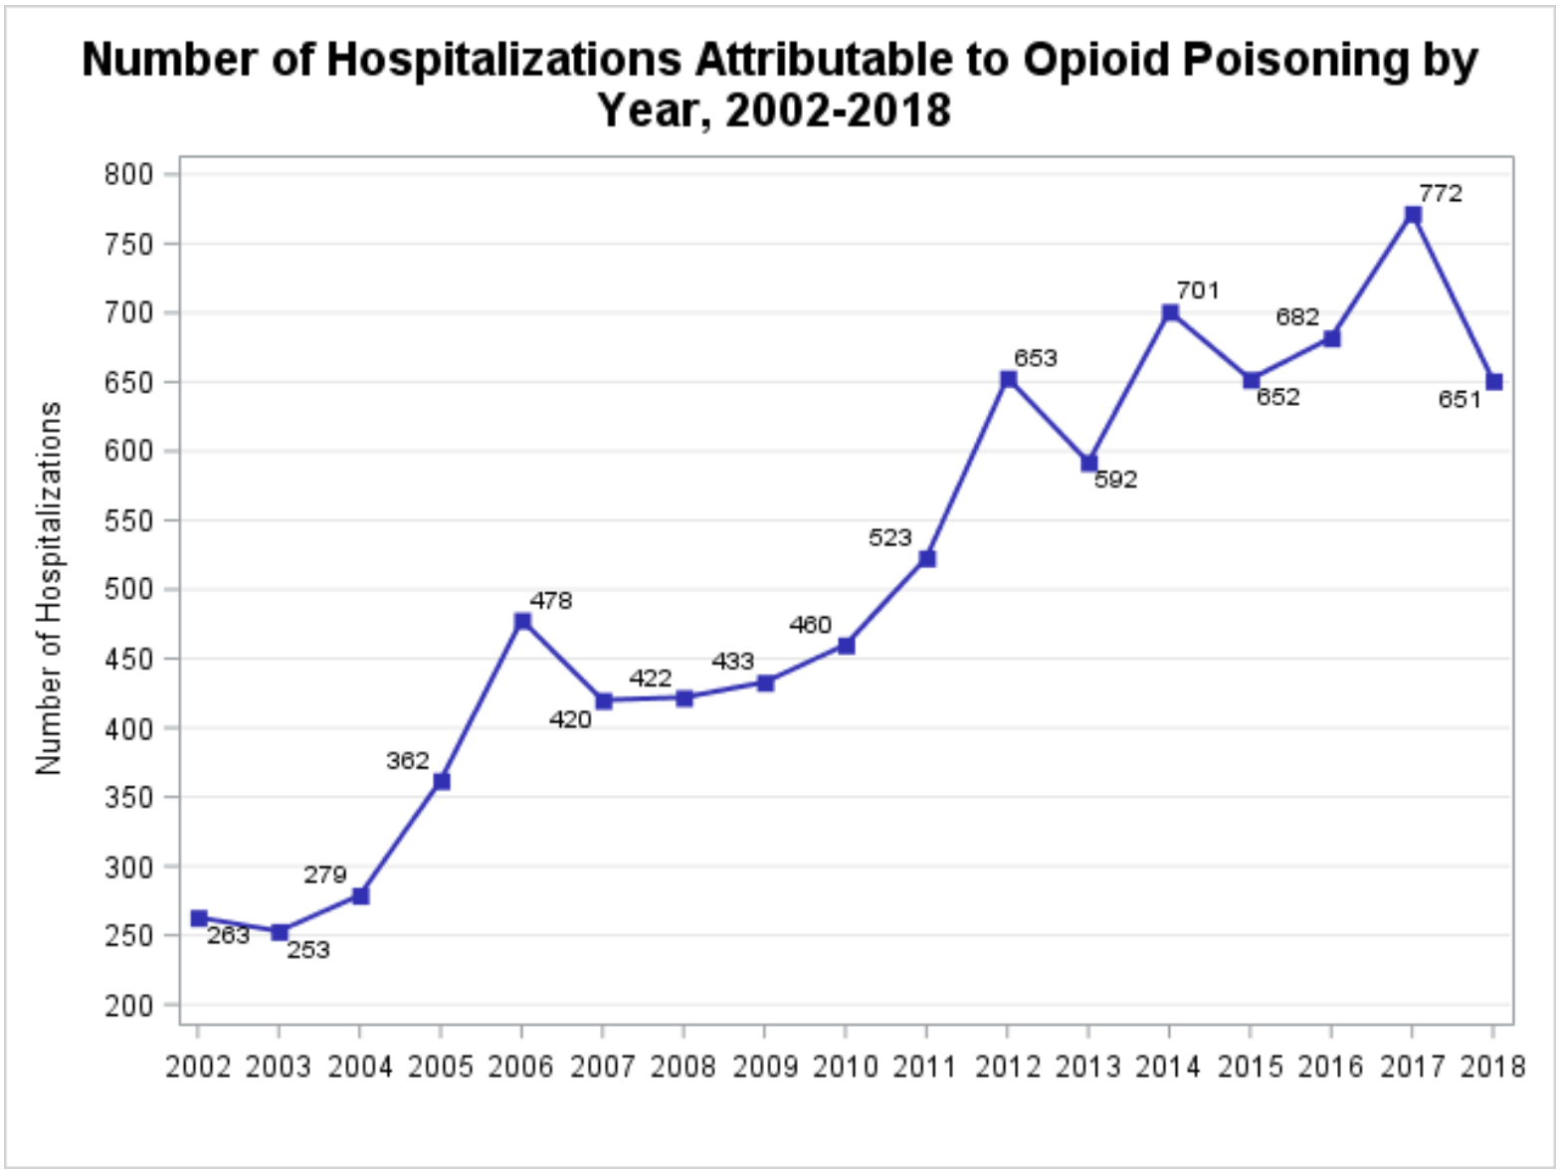

**Figure 1.** Opioid Misuse and Overdose Report, Philadelphia PA (February 13th, 2020 edition)

We endeavored to visualize the process of recovery from addiction as a way of developing understanding of how difficult this can be as well as empathy for people struggling with opioid use disorder (OUD). Our process moved through stages of collecting information and understanding the situation ourselves, organizing that information and creating a visual product.

* Through interviews with project partners and recovery specialists (see section **3.1 Qualitative Data**), we learned that each person struggling with OUD has a unique story of how they got to where they are, and that recovery would look differently to each and involve a unique journey that could include multiple relapses .
* Newer treatments, buprenorphine in particular, offer a wider array of treatment options for opioid users, but the treatment landscape is complicated, with compassion and timely access to resources key to navigating it. We produced a diagram showing this complex landscape.
* We identified several vulnerable populations and key issues and to focus on: homelessness, lack of insurance, mothers, formerly incarcerated people, people with a dual diagnosis of OUD and mental illness, access to Medication Assisted Treatment (MAT), stigma, withdrawal management, lack of compassionate care, lack of timely access to necessary resources.
* We decided to present these issues and other information through stories of individuals, and after considering the pros and cons of actual stories versus composite “personas,” we settled on using one actual story and creating two personas (given time requirements) from the information we collected through the interviews.
* After considering ways to present stories visually, we decided to use “scrollytelling,” which involves having a column of text with accompanying visual elements that change as a reader scrolls through a story online.
* We wrote/edited the content, produced accompanying graphics that include data we collected from various websites (see section **3.2 Quantitative Data**), integrated them into scrollys, and created a landing page that links to the scrollys and could be embedded in partner websites.

**Background**

The 2020 Data Hackathon event was hosted by Code for Philly, DataPhilly, R Ladies and Philly Data Jawn, in partnership with the Health Federation of Philadelphia and Prevention Point. It aimed to gather a community of local data enthusiasts and other volunteers to look for and at available data, and use it to answer pertinent questions around the ongoing opioid crisis in Philadelphia.

The project lasted 6 weeks. Twelve teams met in person and remotely to work on a specific topic. This report describes the work conducted by Team 11, which adopted the topic: “Visualizing the inside journey of the recovery from opioid use disorder.”

**Main Contributors**

**Pete Arriaza** is a front end engineer for the Code for Philly project, Phlask. When he's not teaching himself new software development skills, he plays ultimate frisbee in the Philadelphia Area Disc Alliance (PADA).

**Silvia Canelon** is a postdoctoral research scientist at the University of Pennsylvania utilizing electronic health record data to study the effects of environmental exposures on pregnancy-related health outcomes. She is curious about all intersections of data, society, and reproductive freedom.

**Vince Giorno** is an aspiring data scientist/data analyst who worked as a news editor in Thailand for a number of years. He believes that responsible reliance on data is the antidote to misinformation and disinformation, and that Beethoven, Coltrane and the Grateful Dead are antidotes to too much data.

**Alyssa Hernandez** is a Java student at a coding bootcamp who is switching careers from publishing to software engineering. She is passionate about using technology to drive social change and spends the free time she has writing poetry and working on personal projects.

**Spriha Jha** is a Software Developer at Comcast working with the Business Enterprise team on the software-defined networking (SDN) products. She spends her time attending meetups and volunteering for organizations and is interested in getting into a more data-driven role in the coming future.

**Adnette Kamugisha** is a product manager with SAP in the SAP S/4HANA organization. She joined the Data Hackathon to make a difference and give back to the community in Philadelphia. Her future goals is to join more data hackathons and learn the skills needed to build a community of data enthusiasts in East Africa.

**Benjamin Miller** is a software engineer at Comcast. He spends his free time listening to podcasts and mastering vegan cuisine.

**Catherine Weiss** is a graduate student in computer science at the University of Pennsylvania. She is relaunching her career after first working as a civil engineer and then taking a career break to raise a family. Catherine’s goal is to apply her new technical skills for social good.

**Problem Definition**

Recovery from opioid dependency often is a long and difficult journey, and it will look different for different people. For some, recovery can mean reducing dependency to a minimal level that allows them to successfully maintain their emotional, social, and economic daily life. While many programs are in place to help, recovery is a voluntary commitment from a person who might need continual encouragement and understanding, as well as assistance navigating hurdles they might not be able to overcome on their own, especially if they are going through the agony of withdrawal. Managing withdrawal symptoms is a first step toward long-term treatment, and not recognizing this need and responding to it with compassion and respect can waste an opportunity that might not come around again. Likewise, a failure to provide understanding or timely referrals at any critical point along the recovery process can lead to relapses, creating a vicious cycle of continuous addiction. Understanding what people are going through and what they need are the keys to helping people on their journey toward sustained recovery.

The particular problem that Team 11 worked on was how to visualize the inside journeys of people in Philadelphia dealing with OUD, highlighting the obstacles that can result in setbacks as well as the progress toward recovery that might involve the work of dedicated advocates. The solution we aimed for was to increase empathy among the public at large, with the hope that this empathy would decrease obstacles to recovery. More specifically we aimed to create a final product to offer to any of the partners who would like to use it.

**1. Our Motivation**

A “warm handoff” can successfully transition an individual at any step along the recovery process — such as a visit to an emergency department — to the next step once they are stable and ready. The health.pa.gov website defines a warm handoff as “a collaborative effort between two members of a patient’s healthcare team for the purpose of improving the connection and reducing the gaps in services that the patient will receive.” During a handoff, individuals are assigned to case managers, navigators, or assistants. Their job is to help the individual overcome barriers to accessing the right recovery programs, receiving medications, or simply finding a safe space until a treatment can begin. This process can get very complicated, especially for those who are homeless, suffer from mental illness, or are without proper transportation. The diagram in (**Figure 2**) highlights the complexity of the treatment system. We see these handoffs as a metaphor for the way anyone should treat a person struggling with addiction, and we think that increasing understanding of all that is involved in recovery is a way to turn this metaphor into more of a reality.

**2. Our Approach to the problem**

In order to create a visualization related to recovery from OUD, Data Hack Team 11 spent a considerable amount of time in the first weeks trying to understand the pathways an individual might navigate in order to access MAT. The purpose of this effort was to organize some ground knowledge in a way that could help the team identify areas in the referral process where individuals were likely to face barriers. This would later help the team narrow the scope of the data collection and analysis phases of the project, and ultimately support the creation of a visualization tool for increasing empathy that could be used by the 2020 Data Hackathon Partners — Health Federation of Philadelphia and Prevention Point.

In this initial phase, the team relied almost exclusively on the expertise of the Data Hack partners, team member Jessica Streeter (experience with Community Behavioral Health), Ramon Cruz (lived experience), and Marieke Jackson (public health domain expertise). The knowledge acquired was compiled and processed by the team and organized into a pipeline diagram by Silvia Canelon (Figure 2). The pipeline was used as a reference tool throughout the project and continually updated with each iteration of feedback received.

While the complexity of the diagram reflects the complexity involved in an individual’s access to MAT, it provides insight into only one layer of the multifaceted challenges an individual might experience on their path to recovery.

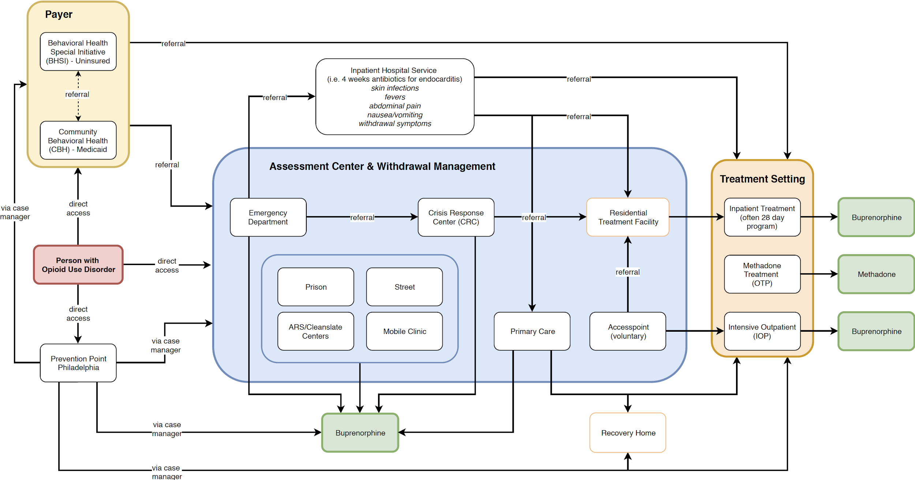

**Figure 2.** Schematic representation of the MAT referral process pipeline as part of the recovery process for a person with OUD

**3. Data Collection**

**3.1 Qualitative Data**

**3.1.1 Interview with Health Federation of Philadelphia**

Catherine Abrams, Opioid Response Program Coordinator at Health Federation of Philadelphia, represented Health Federation as a hackathon partner. She was able to help Data Hack Team 11 establish foundational knowledge about the OUD referral and recovery process. Team members Silvia Canelon, Spriha Jha, and Catherine Weiss participated in an e-mail exchange with her on February 16th, 2020. Additionally, Silvia and Spriha coordinated a video call with Catherine Abrams and her intern Anya Slizik that took place on February 19th, 2020.

The most resonant piece of feedback reflected the importance of centering the individual struggling with OUD throughout the referral and/or recovery process. Catherine described various referral pathways an individual might be led down as they encounter or seek recovery services, information which was incorporated into Figure 2 above. She was also able to highlight some barriers associated with (1) access to treatment, (2) housing and homelessness, and (3) stigma.

*Access to treatment*

Regardless of which entry point an individual comes through, they have a 3-5 hour window of time before experiencing withdrawal symptoms. In addition, the decision to enter treatment may not always align with the Monday-Friday, 9am-5pm schedule maintained by most facilities. In contrast, emergency departments are open 24 hours a day, which might be why they receive a lot of attention. An individual might call a primary care center for an appointment and receive one 5-7 days in the future. To avoid withdrawal symptoms, if an individual is unable to access other services to bridge them until their appointment, they might try to buy buprenorphine on the street or just continue using opioids including heroin or fentanyl, which dramatically increases their risk of death from an overdose. These challenges result in high no-show rates at primary care centers, which are unable to find out if the patient changed their mind, or even if the patient remains alive.

The type of insurance an individual has, whether private or public, may not impact their ability to receive treatment, but can limit the type of treatment service they have access to. Some inpatient treatment programs can be 6 months or longer, but are typically expensive. Peer counselors or recovery specialists can aid in an individual’s recovery but are available as a billable service only at sites certified by the Department of Drug and Alcohol Programs (DDAP). Primary care settings are limited in offering the services of a peer counselor or recovery specialist because they don’t have access to DDAP funding and have to secure funding for these additional services through extra grants. One treatment option, Naltrexone, which is available via injection for individuals without opiates in their system, is not often covered by health insurance unless the individual has already been using it for some time. It should be noted that access to Naltrexone is a limited option for some individuals, because going through the required withdrawal process to satisfy the requirements for receiving the medication is very difficult and can feel impossible.

Some facilities like Addiction Recovery Systems (ARS) and CleanSlate are able to offer buprenorphine to individuals, but only if they satisfy a strict set of criteria. Others like Accesspoint can provide buprenorphine but an individual may have to wait for service for up to 2 days in a room with nothing on the walls, after getting buzzed in through a locked and video-monitored door.

Lack of awareness among healthcare providers can also limit an individual’s access to treatment. For example, many providers in the hospital have the ability to prescribe buprenorphine for 3 days, but aren’t aware or willing of this responsibility and attempt to hand the individual off to another person or facility. This sometimes means the individual does not receive care and forgoes treatment for something else (i.e. a blood infection). Providers also sometimes don’t know they can prescribe Naltrexone as a treatment for OUD, or are reluctant to have difficult conversations with individuals about relapse during the screening process.

In general, there may also be social determinants that impact the type of treatment setting available to an individual in recovery. Some of these social determinants include housing, transportation, educational status, language, culture, employment, parenting responsibilities, socioeconomic status, race/ethnicity, gender identity, and sexual orientation.

*Housing and homelessness*

There are recovery homes available to individuals after residential treatment that are required to accept individuals who take buprenorphine, but where these individuals are stigmatized for using MAT when the majority of residents follow abstinence-only 12-step models. This limits the housing options fully supportive of an individual’s recovery, and for many, not having housing is a barrier to achieving the stability that helps to support recovery. In addition, some individuals experiencing homelessness are wary of medical care and may be more comfortable with a mobile clinic that does not require an appointment, a reality that also impacts the individual’s access to treatment.

*Stigma*

In addition to the stigma described above regarding recovery homes, individuals can be traumatized when they interact with healthcare providers at a time when they are most vulnerable. This can be because providers are placed in a decision-making situation in which they fear enabling an individual with OUD or putting them at risk for overdose, leading them to take measures that can further marginalize the individuals. For example, some providers have only a range of behaviors that they tolerate from an individual, and some programs have strict rules that will cut an individual from the program suddenly. Individuals that are new parents or pregnant often face additional stigma from providers at delivering hospitals and are treated poorly, making them less likely to engage in treatment.

*Describing a successful referral*

A successful referral is measured by the “show rate.” A referral’s ability to be timely and conducive to a individual’s recovery can be influenced by a health center’s ability to provide hours that meet the patient’s needs, account for transportation factors, keep a patient from having to complete lengthy intake processes or waiting periods while in withdrawal, and provide staff that treats individuals in recovery as human beings.

**3.1.2 Interview with Prevention Point Case Managers**

Tracy Esteves-Camacho, Director of Social Services at Prevention Point, was able to coordinate a meeting between members of DataHack Team 11 and several Prevention Point case managers. On March 2, 2020, team members Silvia Canelon, Alyssa Hernandez, and Catherine Weiss met with on-site at Prevention Point (2913 Kensington Ave, Philadelphia, PA) with:

* Megan, drop-in case manager
* Marilyn, drop-in case manager
* Dolores, re-entry case manager/specialist
* Stefanie, medical clinic case manager
* Andrew, mobile clinic case manager

*Participant options*

Prevention Point Philadelphia is a harm reduction organization providing a range of services to participants including syringe services, HIV/HCV testing, hepatitis A and B vaccination services, free medical care, MAT, case management, drop-in center, legal clinic, overdose prevention and reversal training, free meals, mail services, linkage to drug treatment, wound care clinic, and housing services, among others.

The case managers emphasized advocacy and an ability to “expect the unexpected” as critical components of their responsibility to participants. Multiple case managers will often work with the same participant if they require different services at the same time, particularly as they navigate through different parts of their recovery process. When asked about the different barriers to recovery, case managers identified a lack of access to (1) treatment services and (2) resources for vulnerable populations including those experiencing homelessness and/or struggling with mental health challenges. The need to alleviate homelessness in particular was given a lot of weight throughout the conversation and was described as being “the key” to help address some of the barriers faced by the majority of participants seeking services at Prevention Point. Barriers identified are mainly grounded in ineffective policies or regulations and/or stigma.

*Access to treatment*

Participants seeking services at Prevention Point may express a desire to obtain treatment services but not be able to access them. This is true for both inpatient and outpatient services. Inpatient services, both publicly and privately funded, experience bed shortages. In addition, participants with public health insurance have to first undergo withdrawal management and assessment at a Crisis Response Center (CRC) and sometimes have to wait 2-3 days for a bed to become available. Outpatient services can also be difficult to access because it can be hard to book an appointment in a timely manner. The next available appointment may be 1-2 weeks away, so case managers often need to build and maintain relationships with individual healthcare providers throughout the city with the flexibility to squeeze a participant in for outpatient treatment much sooner.

In addition to the difficulty of finding a bed for inpatient services, there is also a lack of access to long-term treatment. Some residential treatment centers only offer short-term (i.e. 13 day) programs and others that offer long-term programs (i.e. 2-3 months) are not accessible to participants on public health insurance. For participants able to receive short-term residential treatment, some treatment centers do not provide a warm hand-off at the end of treatment to any resource other than a shelter, which is not conducive to recovery as it usually also houses individuals in active addiction. The only residential option actively supportive of an individual’s recovery is a recovery house, which could easily carry a 2-month waiting list for participants with public health insurance. Participants often become homeless while they wait for a bed in a recovery house to become available.

*Homelessness and mental health challenges*

Someone experiencing homelessness is supposed to be eligible for public assistance services, but the process is made difficult. Barriers specific to this include requiring proof of a mailing address, asking participants to travel to public assistance offices in other parts of the city, and judgment from caseworkers, among others. Prevention Point case managers knock down as many of these barriers as they can by providing participants with a Philadelphia City ID card, a mailbox that can serve as proof of address, public transportation passes when available, and strong advocacy support when needed, but are often still hindered by other barriers.

Participants experiencing homelessness experience a general lack of stability that can severely impact their recovery, and they move in and out of being housed depending on multiple factors at play. In addition to not being equipped to be explicitly supportive of recovery, shelters are often overcrowded. This means participants have to sleep on the floor in close proximity to other individuals, possibly without a blanket, and worry about bed bugs and lice. They also worry about their belongings being stolen, in addition to being bullied by other individuals. Many choose instead to live on the street, where they might be able to keep their belongings from getting stolen by taking turns staying awake with a trusted person. If they can’t find another person to trust, they might resort to using enough drugs to keep themselves awake. Other individuals could have a slip and start using again after longer-term sobriety. If they are staying with a community whose support is contingent on sobriety, the individual could immediately lose a lot of their resources including housing and support, both of which can result in further isolation. Case managers expressed the importance for all individuals to have access to basic needs like shelter, food, and support for survival, because without them they could start to experience mental health challenges.

Some participants at Prevention Point are dual-diagnosed with OUD and mental health issues. If a participant is experiencing a mental health crisis (i.e. suicidal ideation), a case manager is able to connect them only to a subset of CRCs. This is because some CRCs provide only drug and alcohol services and will ask participants to leave if they mention a mental health diagnosis. The subset of CRCs that work with dual-diagnosed individuals during a mental health crisis are mandated by Community Behavioral Health (the payer) to require participants to sit in a waiting room for a continuous 24 hours in order to confirm the participant does not have drugs in their system and, thus, “prove” the participant is experiencing a mental health crisis. If a participant otherwise shares a mental health history with a case manager, the case manager will refer them to the nearest mental health center and sometimes also has to strongly advocate for the participant when speaking with a health insurance provider reluctant to cover the required care. This effort has resulted in case managers being cursed at and being called names, as well as in additional work associated with making a case for the participant. For participants with a dual-diagnosis that are also experiencing homelessness, the challenges are compounded. Individuals may receive treatment for their mental health diagnosis in the form of medication and have it stolen from them along with the rest of their belongings. If they manage to hold onto their medication, they may have a difficult time properly adhering to their prescription if the medication needs to be taken with food or water, both of which aren’t readily available to someone experiencing homelessness.

*Re-entry after incarceration*

One case manager is a re-entry specialist and shared with us some of the particular challenges faced by participants that have transitioned from incarceration to life in the community. They shared that they specifically work to minimize a participant’s back-and-forth with the prison system. This could include helping participants report for their probations, speaking with public defenders on their behalf, getting bench warrants lifted, and helping them with their finances. The relationship with a participant could begin in prison when a re-entry case manager meets them in person for an assessment and interview, or once a participant is on the outside and seeks Prevention Point services. Re-entry specialists are also able to connect participants with public assistance services, social services, medical care, OUD treatment, and other services as needed. They may advocate for participants for these services themselves or through the integrated network of case managers within Prevention Point.

*Stigma*

Prevention Point case managers shared that stigma is often encountered when they advocate for participants, when participants seek medical services, and when other participants in recovery judge their peers. Case managers face stigma on behalf of the participants they advocate for when they speak to uncooperative third parties such as health insurance or public assistance providers. Participants have disclosed to case managers that they have been stigmatized and treated poorly by healthcare providers when they have received medical care, to the point where they choose to not seek or receive service from certain healthcare providers out of fear of being treated the same way again. Within the recovery community, individuals or organizations that believe in abstinence-only approaches to recovery can stigmatize people using MAT, as can peers entering recovery with Prevention Point that openly judge the behavior or progress of other participants. Common among these different manifestations of stigmatizing behavior was a lack of compassion and/or inability to see those struggling with OUD as human beings.

**3.1.3 Interview with Recovery Specialists at Penn Medicine**

Early in our research, we listened to a Freakonomics podcast episode series entitled, “The Opioid Tragedy” (Dubner & Lapinski, 2020a, 2020b). The second episode of the series puts a spotlight on the work of peer counselors at the University of Pennsylvania (UPenn) hospitals. As the episode explains, peer counselors, who are individuals in recovery themselves, visit OUD patients bedside and begin a conversation about the recovery process. On February 26, 2020, two members of DataHack Team 11, Silvia Canelon and Catherine Weiss, met with Nicole O’Donnell, who had been interviewed on the podcast, and Bryant Rivera, who is also a peer counselor and works with Nicole.

*Options for OUD Patient at Emergency Department*

Nicole and Bryant are certified recovery specialists who work at the three UPenn hospitals. When the hospital identifies a patient as having an OUD they contact Nicole and Bryant, who then visit the patient at their bedside. They explain the three pathways available to the patient:

* Harm reduction counseling;
* Withdrawal management; and
* Treatment.

Patients arrive at the emergency department because they have overdosed or perhaps because of some other illness or injury. In these situations, the patient may not be interested in treatment. Nicole and Bryant find that it’s hard for a patient to commit to anything when they’re sick and in pain. In these cases, they might say to a patient, “If today is not your day, here is how to stay safe.” Harm reduction conversations often include the advice to not use alone, to go slow, and to carry Narcan (naloxone). For patients who will have a lengthy hospital stay, withdrawal management is available. Patients interested in recovery are counseled on types of MAT and presented options for inpatient and outpatient programs.

*Recovery Specialists*

When conversations with the patients do not go well or hit roadblocks, Nicole and Bryant disclose that they are in recovery themselves. They find that it makes patients more comfortable, and that often the “conversations take a turn” and patients disclose more information. They believe that their compassion reduces barriers. Withdrawal is so bad, both mentally and physically, that it means a lot that the recovery specialists have been through it as well. They’re able to say, “I know what it’s like to overdose. I know what withdrawal is like. I have compassion for you.” They said that most patients’ primary emotions are fear, guilt and shame. They’ve also noticed that many people feel angry that they overdosed. Possible reasons for their anger might be because they are no longer high or because their use was revealed.

Recovery specialists have their own challenges. On the very day we met, a recovery specialist from a different organization (a friend of Bryant’s) overdosed and died, and Nicole was on her way to the funeral of another recovery specialist who had died from an overdose a few days before. Nicole and Bryant did not know of any support groups specifically for recovery specialists. They explained how hard it would be to come forward and say you were having problems when it was your job to get others into recovery. They explained that recovery is always a struggle, no matter how far into it a person is.

*Mindset for Recovery*

We learned that the path to recovery is not one overdose or one trip to the Emergency Department (ED) with an infection and then entry into treatment. For most individuals, recovery can involve multiple overdoses, starting recovery programs more than once, and continuing to use opiates (“struggle”) even while attending intensive outpatient programs (IOPs). By having multiple interactions with recovery organizations over a period of time (in the form of harm reduction conversations, getting Narcan to carry, and perhaps trying treatment), the patient will know who to turn to when they are in the proper mindset for recovery.

Nicole and Bryant make relationships with people they met in the hospital and go looking for them [in Kensington] if they haven’t seen them in a while. They “keep tabs” and offer snacks, and in doing so, sometimes “get someone back who has struggled.”

Nicole and Bryant invited a person in recovery, Devin Kloss, to join our meeting. Devin’s recovery story was published in the Philadelphia Inquirer (Whelan, 2019). He explained that people on the street don’t know about all of the services available and how to access Suboxone (a combination of buprenorphine and naloxone).

*Stigma*

Nicole and Bryant spoke about the forms of stigma that exist both within the recovery community and within the healthcare community. Stigma within the recovery community can come from the abstinence community looking down on a person who is participating in MAT. They said that sometimes individuals who participate in abstinence-based support groups have to hide the fact that they also are in MAT. Stigma can manifest in the harm reduction community where some harm reductionists meet someone where they are and this does not include any conversation of what could come next, while other harm reductionists meet someone where they are and also encourage them to imagine something different for themselves. There is even stigma among individuals about their use patterns; Bryant has heard people say, "I only snorted, I never shoot”.

Stigma from the health care community manifests in a lack of compassion during care. Nicole and Bryant told us firsthand that they had been treated poorly by medical health professionals and that this is the reason why individuals often don’t want to come to the ED. Nicole and Bryant also believe that Vivitrol (extended release naltrexone) programs are a kind of stigma-based advocacy. They cite the fact that Vivitrol programs are undersubscribed (because it is not a preferred treatment), yet the Vivitrol programs continue to be offered because the medicine cannot be diverted. They noted that while Suboxone sometimes is diverted, this can be used for a good use on the street.

*Release from Prison*

In the last part of our interview with Nicole and Bryant, we were joined by Dr. Utsha Khatri, an emergency medicine physician with PennMedicine. She stated that the care and treatment of people with OUD who are in jail can be vastly different. She explained that the standard of care in the medical community is to offer buprenorphine, and by federal law, this standard of care must also be offered in jail. Dr. Khatri cited multiple studies that show that the risk of overdose is significantly higher after release from prison. In Oregon, a study showed that the risk of a fatal overdose was 100 times higher in the first two weeks after release from prison as compared to the regular community. Studies in Philadelphia and North Carolina show a risk factor 35-40 times higher than with the general population. A person who used opioids before entering prison has a reduced tolerance when they are released, as does anyone who has not used for a while. Using a dosage they previously used could be fatal. Also, Dr. Khatri believes that the added stressors of re-entry can trigger relapse. She told us that inmates at Philadelphia’s State Road jail are screened for OUD on intake and are screened for withdrawal. They are offered MAT while incarcerated. On the day of discharge, they are supposed to go home with a 5-day blister pack of Suboxone. There is no data at this point that demonstrates that offering treatment during incarceration and linking recently-released inmates to outpatient treatment from the jail are resulting in better outcomes. This is an area which should be studied.

*Stories*

Nicole and Bryant shared two stories with us. Aspects from these stories could be used in future “personas” for the website.

They saw a man in the ED who had been released from jail for about one-and-a-half weeks and had overdosed on a “sprinkle” of heroin. He didn’t think he was going to overdose. He thought he could use just a little bit. As soon as he found out that Nicole and Bryant were in recovery themselves, the conversation went better. The man was angry that he overdosed. He was angry that because he was Narcanned, he wasn’t high. He was also angry because his cover had been blown so everyone knew he was getting high. It had been his secret. He was just “dipping and dabbing”. He didn’t have a habit, so in his mind, he didn’t feel he needed any kind of treatment. Nicole and Bryant had a harm reduction conversation with him, which included ways to stay safe. They told him that fentanyl is in everything, that he can’t use alone, and that he should use slower. They also told him about syringe exchange locations. Nicole and Bryant thought it was an especially sad situation, because he was from another state. He didn’t know whether to return home or stay in Philadelphia.

Nicole and Bryant said that people who are released from jail think they can start from where they left off. They told us that their last reversal in Kensington was someone who was just released from jail. “He was practically dead. He was gray.” Nicole and Bryant gave him Narcan. The man did not want to go in an ambulance because he had been treated poorly in the past. He was more inclined to be helped by Nicole and Bryant who offered him both compassion and snacks. The man did not have a habit. Because of this, he was able to take Suboxone immediately without risk of precipitating withdrawal.

**3.1.4 Online Stories**

Our initial approach was to gather individual recovery stories from surveys, online forums, public social media posts, blogs and interviews available online. Specifically, we were looking for any barriers individuals faced throughout the process to place an emphasis on one person’s experience, as opposed to generalizing the barriers already known through quantitative data. Three of our team members — Vince Giorno, Catherine Weiss, Alyssa Hernandez — were tasked with searching for relevant stories. Alyssa created a survey to distribute online through social media to gather personal accounts, and although not enough data was collected to fully incorporate the responses into our project, some of the answers submitted were used as inspiration for the personas we later created. Some of the other sources we used include Sober Grid, Reddit, Share Your Opioid Story and Kensington Blues. That task proved to be quite difficult as many of our findings were not pertinent to the data we were looking for, such as photographs, memes, religious discussions, etc.

While continuing our search online, we came to the conclusion that interviews with recovery specialists and case managers were more suitable for our project, with the added benefit of providing Philadelphia-specific data. After several rounds of interviews, we decided to focus on a few vulnerable populations that we could represent through various personas: homeless, uninsured, women, formerly incarcerated and people with a dual diagnosis of OUD and mental illness. There were a few stories we found online that included the aforementioned themes, and we ultimately chose one to use from the Share Your Opioid Story website, because it included many of the pain points we were looking for.

To create a more complete picture of individual recovery stories and to avoid identifying anyone who had not publicly shared their story, we chose to piece together the other personas using the information we collected from our interviews (Frey, 2019). We had hoped to cover as many pain points as our research would support, but given our time constraints, we decided to represent as many of our findings as we could in just three personas. Doing so naturally incorporated the fact that people who have OUD often experience several crises that hinder their recovery.

**3.1.5 Recurring Themes in Recovery**

We observed a number of recurring themes in the qualitative data that we collected.

* *Every recovery path is unique.* Often, a person’s recovery is non-linear, includes setbacks and does not have a clear end point. This can make visualizing a journey difficult, because there is no “typical” recovery.
* *The perfect recovery process is the one perfect for that person.* The best recovery process is one that meets an individual exactly where they are, free of external barriers and judgment, and full of respect and compassion.
* *Relapse can happen during recovery.* An individual can relapse but this does not mean that their recovery is over.
* *Mindset for recovery.* Recovery can only begin when a person is ready. Until that point, their access to harm reduction education and harm reduction services is extremely important.
* *Role of long-term relationships* between individuals with OUD and agencies that provide recovery services. Thanks to these long term relationships, a person knows where to turn when they are ready for help.
* *Stigma and recovery.* If an individual was treated poorly in the past by an emergency response person or at a healthy clinic, they may refuse treatment in the future. Some abstinence-based treatment programs do not condone substance use of any kind, including MAT. Stigma exists within advocacy in the form of promoting Vivitrol, which has disadvantages when compared to buprenorphine, but cannot be diverted.
* *Benefit of “Lived Experience”.* When case managers can share that they have “lived experience” and are in recovery themselves, it often makes individuals more comfortable. These case managers are able to offer compassion because they have been through withdrawal and some of the same challenges themselves.
* *Vulnerable Populations.* While there may not be a typical recovery story, it is certain that there are populations for whom there exist even more obstacles to recovery. These vulnerable populations include: homeless, uninsured, mothers, formerly incarcerated, and people with a dual diagnosis of OUD and mental illness.

**3.2 Quantitative Data**

We wanted to supplement and complement individual story arcs with quantitative data that expanded the details of any one narrative into more general observations, particularly on the obstacles faced or pain points experienced by people with OUD as they moved further into the recovery process or relapsed. For example, when the story about Michael, the homeless persona, mentions him being accepted into a residential treatment program, a pair of accompanying charts show how homeless people are much less likely to receive treatment beyond 24-hour rehab than are other people (**Figure 3**).

Adnette Kamugisha, who served as Team 11 leader, and Vince Giorno collected quantitative data from the System Abuse and Mental Health Services Administration database (SAMHSA), the National Institute on Drug Abuse (NIDA), the Philadelphia Department of Public Health, and the Open Data Pennsylvania website.

**3.2.1 SAMHSA**

SAMHSA is the agency within the U.S. Department of Health and Human Services that leads public health efforts to advance the behavioral health of the nation (Substance Abuse and Mental Health Services Administration, 2014). Among the data it makes available in the Substance Abuse and Mental Health Data Archive (SAMHDA) (Substance Abuse and Mental Health Data Archive, 2018) are the Treatment Episode Data Sets, which collect anonymized information about people who undergo treatment at facilities that receive public funding. It publishes an admissions data set, TEDS-A, and a discharges data set, TEDS-D, for each year, and also combines them into multi-year packages to facilitate analysis (Substance Abuse and Mental Health Data Archive, 2017). This project used the TEDS-A 2015-2017 data set, which contains the most recent data available in the archive. Since the records include location data, for the most part the data we used was restricted to data labeled for Philadelphia.

**3.2.2 Opioid Misuse and Overdose Report February 2020 (Department of Public Health, Philadelphia)**

The Opioid Misuse and Overdose Report, is a report published by the Department of Public Health in Philadelphia, to increase public awareness about the opioid crisis (Philadelphia Department of Public Health, 2018). The report describes trends in opioid misuse and overdose in Philadelphia and provides data and graphs to amplify these numbers. This project used the data provided, to try to understand the significance and trends in Philadelphia. Figure 1, is taken directly from this report.

**3.2.3 Open Data Pennsylvania website**

The website provides an Opioid Data Dashboard, with data related to the crisis that Pennsylvania has been facing (Commonwealth of Pennsylvania, 2020). The dashboard was created to provide data to the crisis’s response and visualize its impact to the communities. This project used data from the *data for Emergency Medical Services (EMS) Naloxone Dose Administered by Calendar Year*, to visualize how the number of Naloxone, or Narcan, administrations by emergency personnel went down as the number of people refusing transport to a hospital after these administrations went up. The Open Data Pennsylvania website has a visualization tool that gives the possibility to customize a selected chart by selecting the rights dimensions and measures.

**3.2.4 NIDA**

NIDA, part of the National Institutes of Health, publishes a wealth of information. One online article addressed the situation of people with co-occuring substance abuse and other mental disorders (National Institute on Drug Abuse, 2018). This was directly relevant given that we had highlighted this population as being particularly vulnerable.

**4. Final Product**

**4.1 Personas**

Once we had the basic outlines of the three personas, we needed to create cohesive narratives from snippets of the stories and information we gathered. The guiding principle was to include as many of the issues we highlighted as possible without overloading the narratives. This was simplified somewhat by deciding to use an actual story we found online. This is the story of a woman who was in the military, was in and out of numerous rehabs, and eventually found her way to recovery using MAT. She speaks directly about the stigma she faced as a drug user, and how NA and AA do not work for her. This hits a number of our highlighted issues and also gets in a female voice.

The other two personas required more work. The Michael persona started out as a homeless person. We were able to work in mental illness and insurance problems, as well as the increasing tendency of people not accepting transport to hospital with emergency medical personnel after being revived with naloxone. We also were able to work in two powerful snippets of stories we heard: being forced to stay in a waiting room continuously for 24-48 hours with little or no food so staff could verify that a mental health problem was not caused by drug use, and someone using water from a puddle in the street to mix with heroin they injected, bringing up the issue of medical emergencies ancillary to drug use.

The final of the three initial personas, John, will highlight the obstacles facing people who had been incarcerated, such as the extremely high death rate from overdose in the first year after incarceration, stigma and the lower rate of referrals for MAT from prisons, courts or other arms of the justice system.

**4.2 Website**

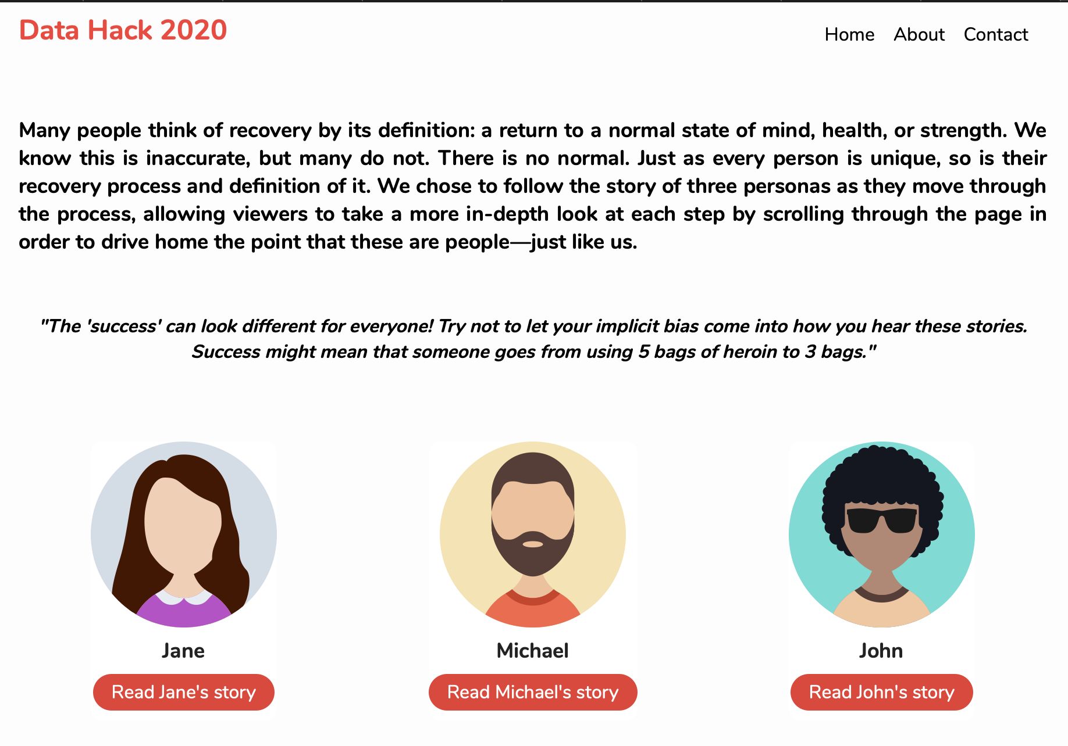

**Figure 3.** Landing page for project website

The culmination of our research is presented in digital form through a website. Users are welcomed to the site with a landing page that displays a brief summary of our topic and how we chose to represent the different stories we investigated. From the landing page, users can navigate through three different personas our team created using many of the recurring themes noted previously with individual stories gathered through interviews or found online.

The stories use “scrollytelling” to add visual elements. As the reader scrolls down the page, a column on the left side of the page moves through the story text (**Figure 4**). A graphic on the right comes into view and “sticks” in place. Each new paragraph transitions the graphic on the right to display data analysis or an emphasized quote that is relevant to that particular paragraph.

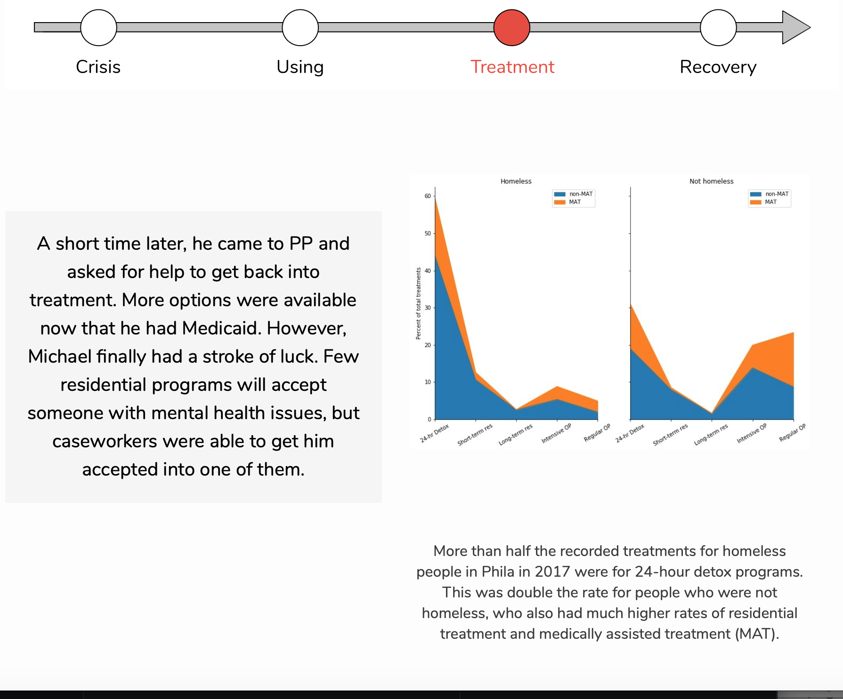

**Figure 4.** Example paragraph from the Michael scrolly

A timeline at the top of the page also appears as the reader starts the story. The timeline has four nodes representing stages of the recovery process: “Crisis”, “Using”, “Treatment”, and “Recovery”. Each paragraph of the story is correlated to a stage in the timeline and as the reader scrolls to that paragraph the respective node is highlighted. Despite being a timeline, the stories follow a non-linear path towards “Recovery”, highlighting the many setbacks a person experiences during the recovery process. The timeline is also shown as an arrow to represent that recovery is a lifelong, continual process without a definitive end.

*Technical Details*

We used multiple tools to create the website, namely the scrollama, D3, and SVG Javascript libraries (Spriha Jha, Ben Miller and Alyssa Hernandez). Using these tools we were able to create a more engaging user experience by scripting animated widgets (Pete Arriaza) and data visualizations (Vince). Most of the graphs and charts were produced using Python and the pandas and matplotlib libraries. A few used the Infogram online tool.

Much of the team’s technical work resided in researching, formatting, and generating data visualizations that could be embedded into the website. Data visualizations had to correspond to a persona, as well as have an impactful message. We had to discard or abandon some visualizations that could not be effective parts of the final product.

After research and content development were completed, our team had to assemble its work into an HTML document and host it (Spriha). We are confident in our ability to encapsulate our deliverable into an iframe that could be embedded in any Code for Philly partner website.

**5. References**

Commonwealth of Pennsylvania. (2020). Pennsylvania Opioids. PA Open Data Portal. https://data.pa.gov/stories/s/9q45-nckt

Dubner, S. J., & Lapinski, Z. (2020a). The Opioid Tragedy, Part 1: “We’ve Addicted an Entire Generation.” Freakonomics Radio.

Dubner, S. J., & Lapinski, Z. (2020b). The Opioid Tragedy, Part 2: “It’s Not a Death Sentence.” Freakonomics Radio.

Frey, N. (2019). Nicole F., Northampton County, PA. Share Your Opioid Story. https://shareyouropioidstory.com/nicole-f-northampton-county-pa/

National Institute on Drug Abuse. (2018). Comorbidity: Substance Use and Other Mental Disorders. Trends & Statistics. https://www.drugabuse.gov/related-topics/trends-statistics/infographics/comorbidity-substance-use-other-mental-disorders

Philadelphia Department of Public Health. (2018). Opioid Misuse and Overdose Report (Issue February).

Substance Abuse and Mental Health Data Archive. (2017). Treatment Episode Data Set: Admissions (TEDS-A). https://www.datafiles.samhsa.gov/study-series/treatment-episode-data-set-admissions-teds-nid13518

Substance Abuse and Mental Health Data Archive. (2018). About the SAMHDA Project. https://datafiles.samhsa.gov/info/about-samhda-project-nid14

Substance Abuse and Mental Health Services Administration. (2014). About Us. https://www.samhsa.gov/about-us

Whelan, A. (2019). At Penn, people in recovery are helping more patients with addiction enter treatment. The Philadelphia Inquirer.